Section 1 per lab

Controls lab 2

By FRSKIA001 Kian frassek
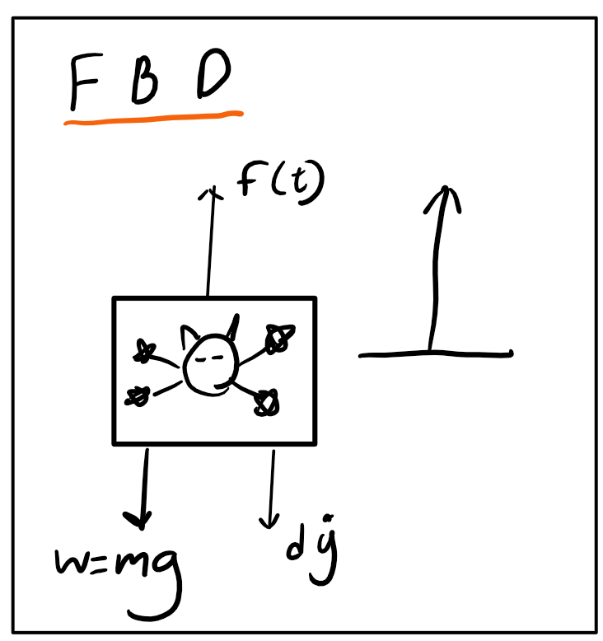

A) Block diagram
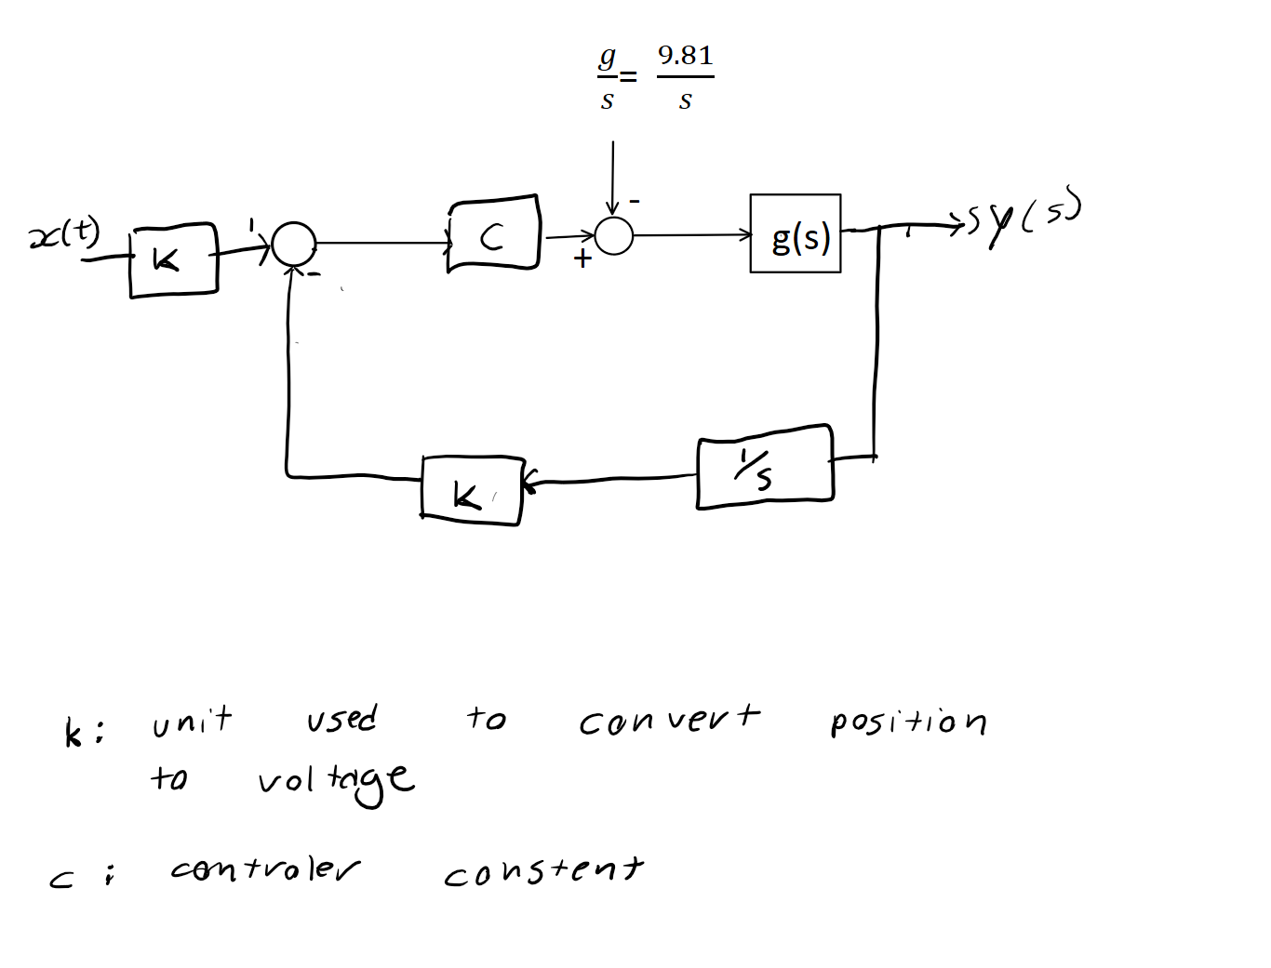

B) Diffraction equation

C) deriving G(s) closed loop

b)

i)

II)type 1
iii) should be zero.

C) Simulink

